Addison Babcock, 200013782

Instructor: Dario Medele

October 28th, 2015

Golf Course Manager

Elaboration Document

Table of Contents

Vision for Golf Course Manager 4

Stakeholders 4

Proposed Solution 4

Actors 4

Glossary 6

Use Case Specifications 7

Use Case Model 7

Use Case Descriptions 8

Create Reservation 8

View/Update/Cancel Reservation 8

View Membership Status and Details 8

View Daily List of Reservations 8

Update Membership 8

Schedule Tournaments 8

Create and Update Membership Levels and Pricing 8

View Membership Reports 8

View Available Reservation Slots 9

Apply Discounts 9

Fully Dressed Use Cases 9

Create Reservation 9

Cancel Reservation 12

Supplementary Specifications 15

Functional 15

Features 15

Security 15

Usability 15

Human factors 15

Help 16

Documentation 16

Reliability 16

Frequency of failure 16

Recoverability 16

Performance 16

Response times 16

Throughput 16

Accuracy 16

Availability 16

Resource usage 16

Supportability 16

Adaptability 16

Maintainability 16

Internationalization 16

Configurability 17

Implementation 17

Resource limitations 17

Languages and tools 17

Hardware 17

Interface 17

Operations 17

Packaging 17

Legal 17

Architectural Factors 17

Factor 17

Measures and quality scenarios 17

Variability (current flexibility and future evolution) 18

Logical Architecture Diagram 18

Use Case Realization 19

Technical Memos 19

Issue: Mobile Compatibility 19

Issue: Expandability 20

Implementation View 21

Class Diagram 22

Data View 23

Data Dictionary 23

Test Plans 25

Create Reservation Test Plan 25

Scenario #1 25

Scenario #2 25

Cancel Reservation Test Plan 25

Scenario #1 25

Scenario #2 26

Risk List 26

Iteration Plan 27

Business Bid 27

Project Schedule 27

Project Plan 27

Phase: Construction 27

Phase: Transition 27

Return on Investment 28

Stakeholder Benefits 28

Software Architecture Document 29

Architectural Representation 29

# Vision for Golf Course Manager

Currently the reservation and member management system for Club BAIST is manual and paper based. Club BAIST members call in to the office in order to make or cancel a reservation. This can be problematic if the office staff are busy as there is a penalty to members who do not use their reservations. Club BAIST would like to provide its members with a website that will allow them to create and manage reservations without having to call in.

## Stakeholders

The stakeholders for this project include the Club BAIST clubhouse staff, the Club BAIST front office staff, Club BAIST management, the Club BAIST members, the Club BAIST Finance Committee, the Club BAIST Membership Committee as well as the Club BAIST board of directors.

The Club BAIST clubhouse staff needs to be able to review a daily list of reservations and indicate whether the Club BAIST Members have played their reservation.

The Club BAIST front office staff needs to be able to book and cancel reservations. They also need to be able to review applications and inform Club BAIST members about the application and account status. Club BAIST front office staff need to be able to accept payments for memberships.

The Club BAIST management need to be able to provide discounts as well as cancel memberships. The Club BAIST management also needs to be able to override the reservation system and set up tournament booking.

The Club BAIST Finance Committee needs to be able to be able to update the membership levels and annual pricing. The Club BAIST Finance Committee also needs to be able to track each Club BAIST Members account and their activity at the club.

The Club BAIST Membership Committee needs to be able to be able to update the membership levels and pull reports on memberships and their statuses. The Club BAIST Membership Committee needs to be able to review and approve membership applications.

The Club BAIST Board of Directors needs to be able to be able to pull reports, including lists of memberships and their statuses. They also need to be kept up to date on the progress of this project.

## Proposed Solution

The solution will be built as an external and internal facing website with an N-tier architecture backed by a database. The website will need to be mobile friendly to allow for easy reservations by the Club BAIST Members.

## Actors

Club BAIST Members – Add and cancel reservations. Apply for new reservations and vouch for new membership applications. Pay for membership fees. Change membership level. View membership status. View their reservations.

Club BAIST Clubhouse Staff – Review a daily list of reservations. Indicate whether the reservation was used.

Club BAIST Front Office Staff – Book and cancel reservations. Review applications. Accept payments for reservations.

Club BAIST Management – Provide discounts, cancel memberships, override reservation system, and set up tournament booking.

Club BAIST Finance Committee – Update membership levels and annual pricing. Track each members account and activity.

Club BAIST Membership Committee – Update membership levels, pulls reports on memberships and their status. Review and approve membership applications.

Club BAIST Board of Directors – Pull reports on memberships.

# Glossary

Golf Course Manager - The software being built in this project.

Club BAIST Clubhouse Staff - The group of staff who are stationed at the first hole. They are responsible for allowing players to tee off and verifying that they have a reservation. They also take note of when Club BAIST Members show or don’t show for a reservation.

Club BAIST Front Office Staff - The group of staff who are stationed inside the office. They are responsible for answering phones and for creating and cancelling reservations. They need to be able to inform Club BAIST Members of their application, financial, and reservation status.

Club BAIST Management - The group of staff who manage day to day operations at Club BAIST. They are able to set up special events and override the reservation system in case of conflicts. They are also able to provide discounts.

Club BAIST Finance Committee - The Club BAIST Finance Committee is able to view reports of Club BAIST Members and their payment status. The Club BAIST Finance Committee is composed of staff who might also be a part of other groups.

Club BAIST Membership Committee - The Club BAIST Membership Committee is responsible for approving new memberships. The Club BAIST Membership Committee is composed of staff who might also be a part of other groups.

Club BAIST Members - This is the group of people who have at minimum a membership application in the system.

Tee Time - A time slot is a tee off time which is available to be booked or is already booked. These can be occupied by members or by tournaments or they can be empty.

Membership Level - The system will support different membership levels. A higher Membership Level can bump the reservations of Club BAIST Members with lower Membership Levels.

User - A user is an individual person using the system. This person might not be authenticated and can have any level of authorization.

# Use Case Specifications

## Use Case Model

Golf Course Manager

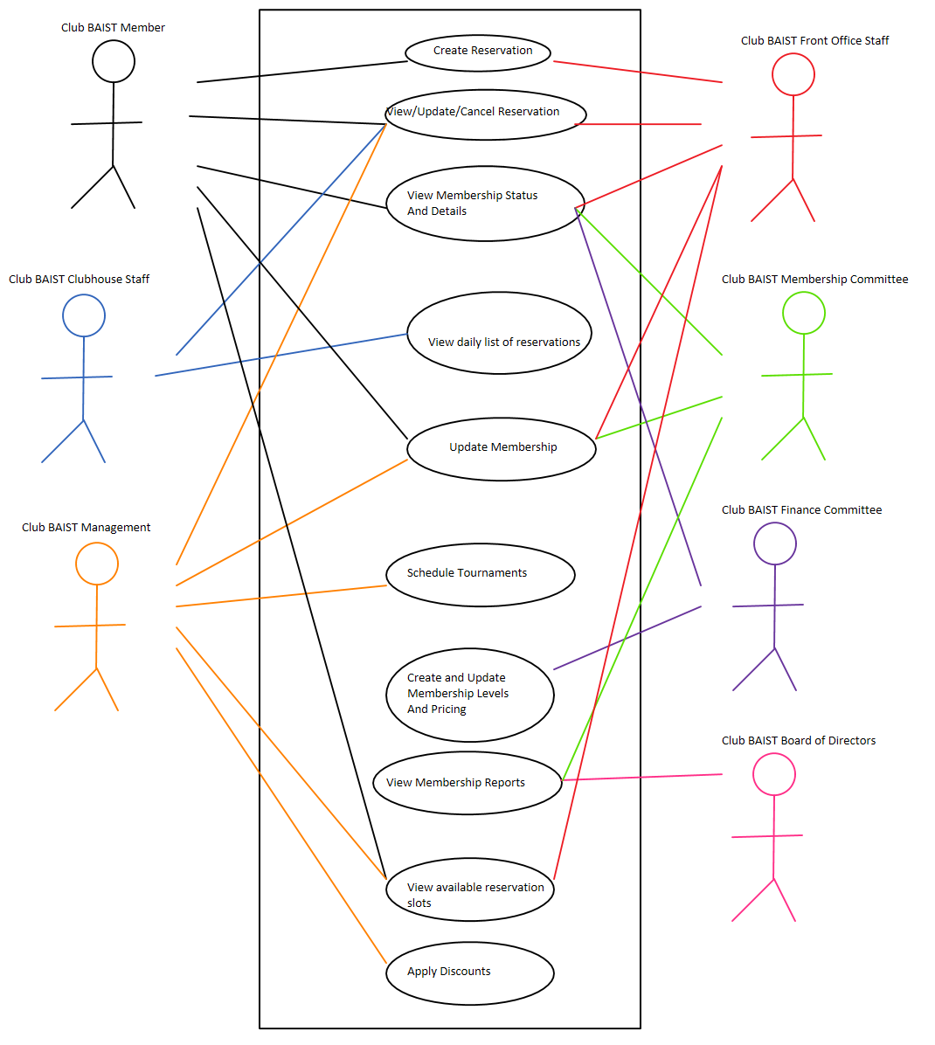

## Use Case Descriptions

### Create Reservation

The Club BAIST Member wishes to reserve a tee time for themselves and up to 3 other people. The desired time slot must be available and the Club BAIST Member must be in good standing. The desired time slot must be for a future date (same day is not allowed). If successful, the system will mark that time slot as reserved by the Club BAIST Member. This use case will also be available to Club BAIST Front Office Staff who can create reservations for Club BAIST Members who call in over the phone or who are in the office. This use case will need to be able to create a recurring standing reservation.

### View/Update/Cancel Reservation

The Club BAIST Member wishes to view or cancel or update their current reservation. Cancelling or changing the time of a reservation will free up that time slot for use by other Club BAIST Members. Club BAIST Clubhouse Staff will be able to mark the reservation as fulfilled when the Club BAIST Member tees off on time. Club BAIST Front Office Staff will be able to use this use case on behalf of Club BAIST Members. Club BAIST Management will be able to use this use case when needed.

### View Membership Status and Details

The Club BAIST Members will be able to review their membership status and their demographic information. This will allow them to view important details like whether their applications have been approved, payments have been accepted, and so on.

### View Daily List of Reservations

The Club BAIST Clubhouse Staff need to be able to print a list of the days’ time slots. They will mark each reservation as fulfilled as the Club BAIST Member tees off. This list should have the Club BAIST Members and their party’s names.

### Update Membership

Club BAIST Members and Club BAIST Front Office Staff will be able to update their contact and demographic information as well as change the Club BAIST Members level through this use case. The Club BAIST Membership Committee and Club BAIST Management will use this use case to approve and cancel memberships.

### Schedule Tournaments

Club BAIST Management needs to be able to create large blocks of reservations easily for tournaments. If a time slot is already occupied by a prior reservation that reservation will be automatically cancelled.

### Create and Update Membership Levels and Pricing

The system needs to be flexible enough to accommodate changes to the membership levels and their pricing. This use case will be available to the Club BAIST Finance Committee. The updated membership levels and pricing will be reflected on the next invoice for Club BAIST Members.

### View Membership Reports

The Club BAIST Finance Committee and the Club BAIST Board of Directors need to be able to review how the Club BAIST Golf Club is performing. What reports are required have not been determined yet but will likely include monthly approved memberships, monthly total memberships broken down by Membership Level and Club BAIST Members who have not paid their dues.

### View Available Reservation Slots

Club BAIST Members, Club BAIST Front Office Staff and Club BAIST Management need to be able to view the available Time Slots for a given day. From there the person using this use case will be able to create a reservation. If a Time Slot is currently reserved by a Club BAIST Member with a lower Membership Level than the Club BAIST Member using the use case, that Time Slot will be shown as available. If Club BAIST Management is using this use case, the reserved Time Slots will show the name of the Club BAIST Member who has reserved that Time Slot.

### Apply Discounts

Club BAIST Management needs to be able to apply discounts to in case of Club BAIST Member complaints. The discounts will only apply to membership fees.

## Fully Dressed Use Cases

### Create Reservation

Use Case Name: Create Reservation

Description: Used by Club BAIST Members to reserve a tee time.

Stakeholders: Club BAIST Members

Actors: Club BAIST Member

Pre-conditions: The person using this use case must be authenticated and authorized as one of the actors listed above. The tee time must be available (not previously reserved, not during a tournament, not outside of Club BAIST hours).

Success: The tee time will be marked as reserved by the Club BAIST Member

Main Scenario:

1. The Club BAIST Member loads the reservation UI.
2. The system validates that the Club BAIST Member has been authorized to reserve tee times.
3. The Club BAIST Member is presented with a list of tee times for the current week. Available tee times are shown in green and unavailable times are shown in red.
4. The Club BAIST Member can advance to the next week or go back to the previous week.
5. The Club BAIST Member selects a tee time.
6. The Club BAIST Member then enters the names of the players who will be participating. The Club BAIST Members name will automatically be filled in the first slot. Up to 4 players total per tee time.
7. The system will then display UI allowing the Club BAIST Member to confirm or cancel the tee time.
8. The Club BAIST Member confirms the tee time.
9. The system performs another check to ensure the Club BAIST Member is in good standing and that the tee time is available.
10. The tee time is marked as reserved in the system.
11. The system displays a confirmation to the Club BAIST Member.

Extensions:

1. If the Club BAIST Member is not authorized to reserve tee times then the system will display an error message and the Club BAIST Member will not be allowed to reserve tee times.
2. If the tee time is unavailable an error will be displayed describing the reason why. The Club BAIST Member will be able to select another tee time.
3. If the Club BAIST Member cancels they will be taken back to select another tee time. The names of the players will be stored in temporary memory instead of being cleared.
   1. If the Club BAIST Member is not in good standing an error will be displayed. The reservation will not complete.
   2. If the tee time is no longer available an error will be displayed. The Club BAIST Member will be allowed to select another tee time.
4. If the reservation fails in the system an error will be displayed describing why. The Club BAIST Member will be allowed to retry or be given the phone number for the Club BAIST Front Office.

Special Requirements:

* The loading of the weekly calendar view must take less than 0.5 seconds.
* The final confirmation step must take less than 0.5 seconds.
* The system cannot allow multiple Club BAIST Members to reserve the same tee time.

#### UI Prototype

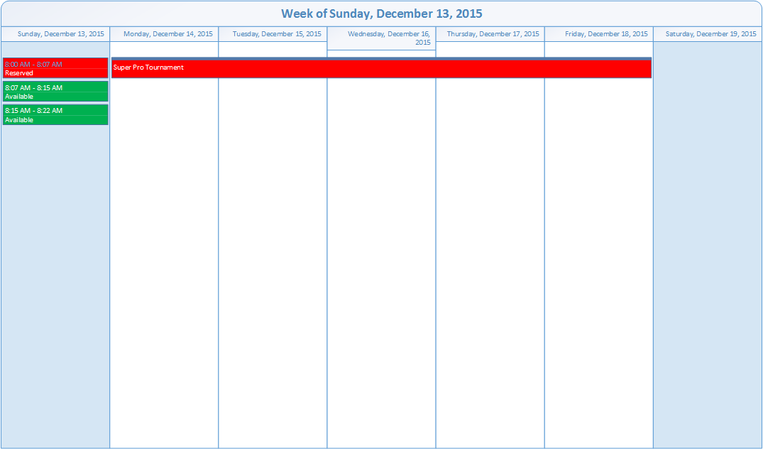

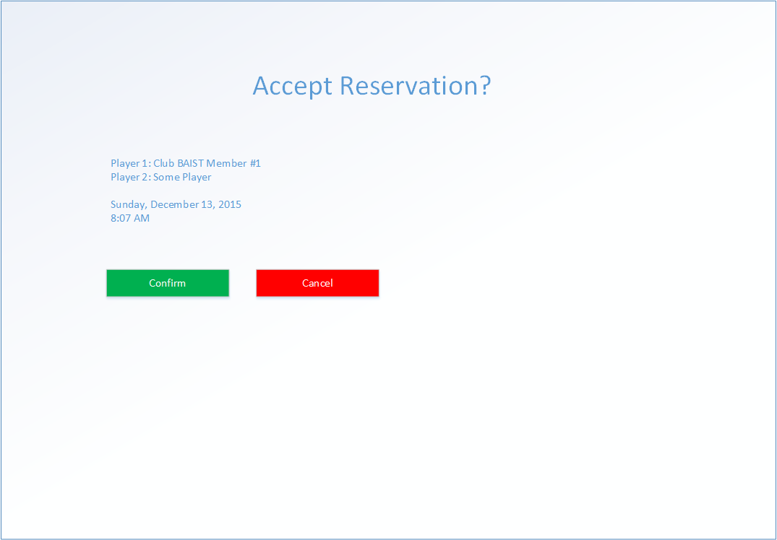

#### System Sequence Diagram

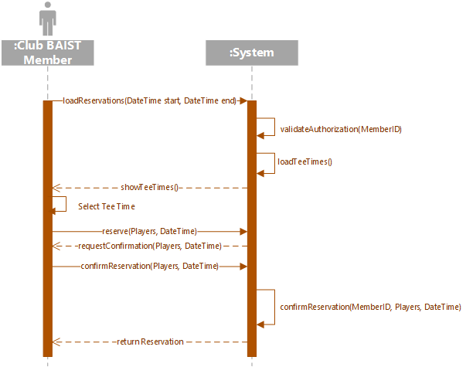

### Cancel Reservation

Use Case Name: Cancel Reservation

Description: Used by Club BAIST Members to cancel a tee time.

Stakeholders: Club BAIST Members

Actors: Club BAIST Member

Pre-conditions: The person using this use case must be authenticated and authorized as one of the actors listed above. The Club BAIST Member must have reservations to cancel.

Success: The tee time will no longer be marked as reserved by the Club BAIST Member.

Main Scenario:

1. The Club BAIST Member loads the cancellation UI.
2. The Club BAIST Member is presented with a list of upcoming reserved tee times belonging to that Club BAIST Member.
3. The Club BAIST Member selects one of the tee times from the list.
4. The system presents dialog asking the Club BAIST Member to confirm their selection.
5. The Club BAIST Member confirms the cancellation.
6. The system marks the tee time as available.
7. A confirmation is displayed to the Club BAIST Member.

Extensions:

1. If the Club BAIST Member has no upcoming tee times a message will be displayed instead.
2. If the Club BAIST Member cancels, the tee time will remain reserved. The Club BAIST Member will be allowed to select another tee time (#2).

Special Requirements:

* The loading of the list of upcoming reserved tee times must take less than 0.5 seconds.
* The final cancellation must take less than 0.5 seconds.

#### UI Prototype



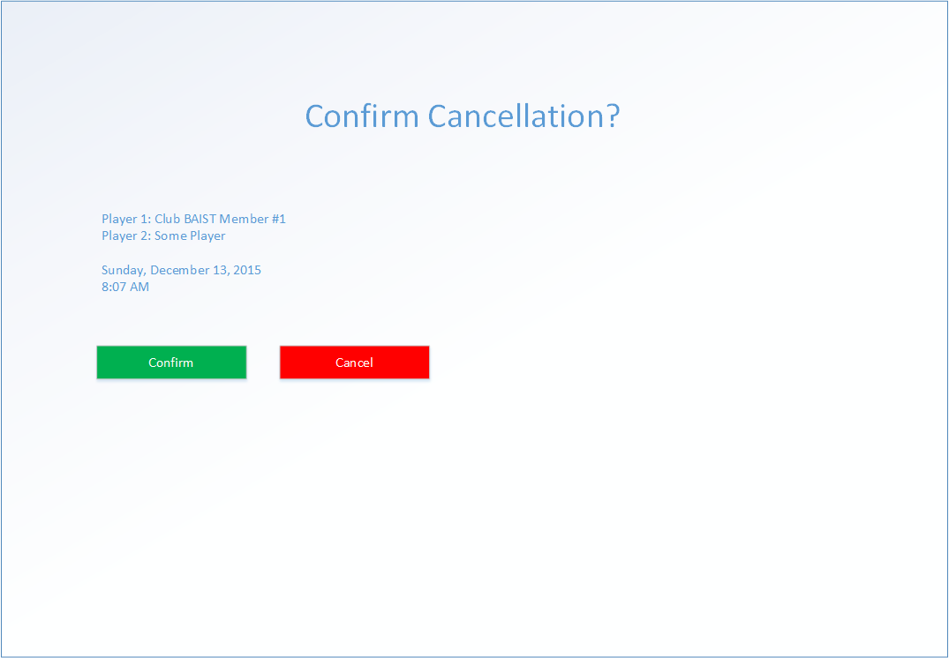

#### System Sequence Diagram

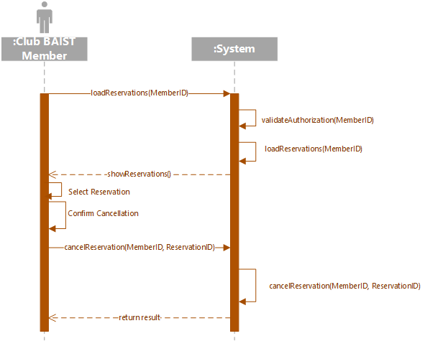

# Supplementary Specifications

## Functional

### Features

* Log authentication errors to persistent storage.
* Log reservation activity.
* Notify Club BAIST Members if their reservation gets bumped.

### Security

* Authentication will be required before any functionality is usable.
* Different use cases will be enabled depending on the capabilities the user has. A user might belong to multiple authorization groups.

## Usability

### Human factors

* The interface will need to be usable as a desktop website and a mobile website.
* The website will be public facing so be careful of unnecessary jargon.

### Help

* Support for this software will be provided by us during regular business hours.

### Documentation

* Documentation will be supplied for all user facing functionality.

## Reliability

### Frequency of failure

* The system is critical to the success of Club BAIST. We will aim for 99.9% reliability (8.8 hours downtime per year).

### Recoverability

* We will be making daily incremental backups in addition to weekly full backups. We will build the system to allow for server side redundancy.

## Performance

### Response times

* The system should spend less than 50 milliseconds building the majority of pages. Network response might vary but should be less than 10 milliseconds on the local network.

### Throughput

* The system should be able to handle up to 20 simultaneous users.

### Accuracy

* Accuracy should generally not be an issue.

### Availability

* Because the Club BAIST offices are in a remote location the software will be hosted in the cloud. An internet connection to the site might not be reliable but the Golf Course Manager software will continue to be available to Club BAIST Members.

### Resource usage

* Resource usage should be in line with similar small e-commerce sites.

## Supportability

### Adaptability

* We should consider building this software to allow for multiple golf courses running on the same software.

### Maintainability

### Internationalization

* No internationalization is required for this application. It will be written in Canadian English.

### Configurability

* The Time Slots need to be configurable. The Membership Levels need to be configurable. Tax rates need to be configurable.

## Implementation

### Resource limitations

* Because the web pages will be mobile-friendly they should be written to not consume excessive bandwidth.

### Languages and tools

* The software will be written in ASP.Net using C# with SQL backend.

### Hardware

* We will need to install POS computers, networking and printers in the Club BAIST office. The server software will run in the cloud to save on hardware costs and minimize the dependency of Club BAIST on an internet connection.

## Interface

* The interface needs to be responsive to the user’s device.

## Operations

* The system does not currently require significant operator oversight. We will need to ensure that backups run correctly.

## Packaging

* This software will not be physically packaged.

## Legal

* The software will be developed for and licensed to a single client, Club BAIST. We will maintain ownership of the source code so we can license it to other clients should the need arise.

## Architectural Factors

### Factor

* The software needs to respond quickly to user requests.
* The software needs to be themed in case we want to license it to other golf courses.

### Measures and quality scenarios

* The software will be considered high quality if:
* Low response times.
* Low support calls.
* Majority of Club BAIST Members using the software.
* Club BAIST Members can easily and quickly create reservations.

### Variability (current flexibility and future evolution)

* The current system will be flexible enough to allow for changes to the Club BAIST hours and tee-off frequency. The current system will be flexible enough to allow for changes to the Membership Levels and pricing.
* In the future the system should be flexible enough to allow for multiple golf courses.

# Logical Architecture Diagram

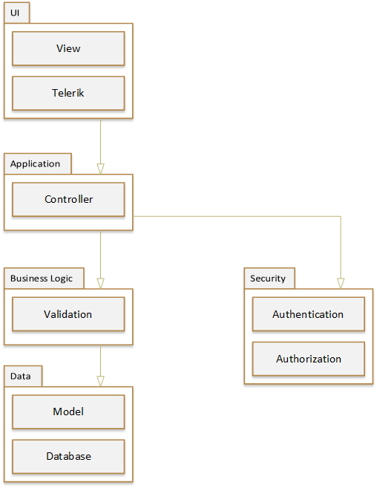

# Use Case Realization

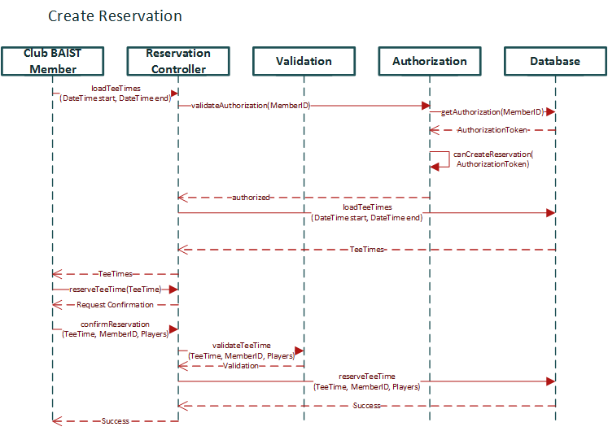

# Technical Memos

## Issue: Mobile Compatibility

Solution Summary: The UI needs to be responsive to various device sizes and capabilities.

Factors: Club BAIST Members need to be able to create and cancel reservations using their preferred device.

Solution:

* Use an appropriate library to help UI responsiveness.
* Use the hamburger menu to help collapse functionality.

Motivation:

* Encourage Club BAIST Members to cancel reservations early so they can be booked by others.
* Use as a sales tool to enlist new Club BAIST Members.
* Free up staff work load.

Unresolved Issues:

* Smart watches will be a challenge.

Alternatives Considered:

* Single website with zooming and scrolling. Too painful to use.

## Issue: Expandability

Solution Summary: The application needs to be capable of supporting multiple golf courses on a single instance at a future date.

Factors: We can help make the project more profitable by licensing our technology to other golf courses with little change.

Solution:

* A theme-able design will be needed.
* The data design needs to allow for multiple independent golf courses.
* A user should not have to specify which course they belong to when they are authenticating.

Motivation:

* Once the software has been built and deployed it will be easy to license to other golf courses. This can provide us with additional revenue for little work.
* Club BAIST will be able to expand to another golf course in the future without much effort on our part.

Unresolved Issues:

* How to allow a single user account to take part in multiple golf courses.

Alternatives Considered:

* Deploying multiple instances of the application will be difficult to update and maintain. It will also be difficult to migrate to the cloud.

# Implementation View

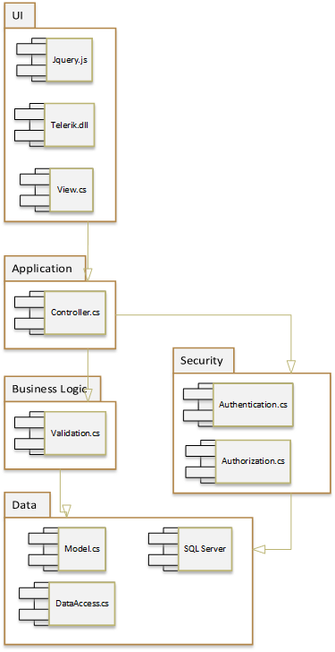

# Class Diagram



# Data View



# Data Dictionary

Table: GolfCourse

Columns:

* CourseID: Int, PK
* CourseName: String
* TeeTimeInterval: Time
* OpenMonday: Time
* CloseMonday: Time
* OpenTuesday: Time
* CloseTuesday: Time
* OpenWednesday: Time
* CloseWednesday: Time
* OpenThursday: Time
* CloseThursday: Time
* OpenFriday: Time
* CloseFriday: Time
* OpenSaturday: Time
* CloseSaturday: Time
* OpenSunday: Time
* CloseSunday: Time

Table: Employee

Columns:

* EmployeeID: Int, PK
* CourseID: Int, FK
* CredentialsID: Int, FK
* Fullname: String
* Login: String
* Password: String

Table: Credentials

Columns:

* ID: Int, PK
* CourseID: Int, FK
* Description: Name

Table: Member

Columns:

* MemberID: Int, PK
* CourseID: Int, FK
* CredentialsID: Int, FK
* Fullname: String
* Address1: String
* Address2: String
* Address3: String
* City: String
* Province: String
* PC: String
* Status: String
* Login: String
* Password: String

Table: TeeTime

Columns:

* MemberID: int, FK, Null
* CourseID, int, PK
* Player1: String
* Player2: String
* Player3: String
* Player4: String
* Start: DateTime, PK
* End: DateTime

Table: Score

Columns:

* CourseID: Int, FK
* HoleNumber: Int, FK, PK
* TeeTimeStart: DateTime, PK
* MemberID: Int, FK
* PlayerName: String
* Strokes: Int

Table: Hole

Columns:

* CourseID: Int, PK, FK
* HoleNumber: Int, PK
* Par: Int
* YardsWhite: Int
* YardsRed: Int
* YardsBlue: Int

# Test Plans

## Create Reservation Test Plan

### Scenario #1

1. Login as a Club BAIST Member with an active membership.
2. Select the Reserve Tee Time page.
3. Select an available Tee Time.
4. Select Confirm.
5. Check the database to ensure the Tee Time was reserved properly.

### Scenario #2

1. Login as a Club BAIST Member with an inactive membership.
2. Select the Reserve Tee Time page.
3. Select an available Tee Time.
4. The Club BAIST Member should be stopped at this point.

## Cancel Reservation Test Plan

### Scenario #1

1. Login as a Club BAIST Member with an active membership and pending reserved Tee Times.
2. Select the View Tee Times page.
3. Select a Tee Time from the list to cancel.
4. Select Confirm.
5. Check the database to ensure the Tee Time was cancelled properly.

### Scenario #2

1. Login as a Club BAIST Member with an active membership and no pending reserved Tee Times.
2. Select the View Tee Times page.
3. The page should be empty.

# Risk List

|  |  |  |
| --- | --- | --- |
| Ranking | Use Case | Reason |
| High | Create Reservation | This use case is critical to the system. The algorithm to bump Club BAIST Members with lower Membership Levels might be tricky. |
| High | View/Update/Cancel Reservation | Updating a reservation might need to bump a reservation similar to the Create Reservation use case. If a Time Slot is freed up that was previously bumped the system might need to inform the other Club BAIST Member. |
| High | Schedule Tournament | This use case needs to be able to bump reservations when a reservation conflicts with a tournament. |
| Medium | Create and Update Membership Levels and Pricing | There is a lot of complexity involved in this use case however it’s likely to be used rarely. |
| Medium | Update Membership | Differently authorized users will be able to do different things here. |
| Medium | View Available Reservation Slots | There is some business logic involved in this use case and it links to other use cases. |
| Medium | Apply Discounts | We need to be able to account for discounts from Club BAIST Management. |
| Low | View Membership Status and Details | A fairly simple use case, only involves retrieving and displaying information. |
| Low | View Daily List of Reservations | A fairly simple use case, only involves retrieving and displaying information. |
| Low | View Membership Reports | The type of reports being generated will likely not have a significant architectural impact. They will also be run rarely. |

# Iteration Plan

Phase: Construction

Iteration: 1

|  |  |  |  |  |
| --- | --- | --- | --- | --- |
| Core Workflow Discipline | Use Case | Activity | Time | Resources |
| Coding | Create Reservation | Use case development | 40 | Developer |
| Coding | Cancel Reservation | Use case development | 32 | Developer |
| Testing | Create Reservation | Unit Testing | 20 | Tester |
| Testing | Cancel Reservation | Unit Testing | 20 | Tester |
| UI Design | Create Reservation | User Interface Development | 40 | Designer |
| UI Design | Cancel Reservation | User Interface Development | 40 | Designer |
| Coding | All | Stored Procedure Development | 120 | DBA |
| Database Design | Implement Schema | Create database tables | 20 | DBA |

# Business Bid

## Project Schedule

Phase: Construction

|  |  |  |  |  |
| --- | --- | --- | --- | --- |
| Iteration | Minor Milestone | Start Date | End Date | Resources |
| 1 | Alpha 1 | January 1, 2016 | January 31, 2016 | Developer, Tester, Designer, DBA |
| 2 | Alpha 2 | February 1, 2016 | February 29, 2016 | Developer, Tester (2), Designer, DBA |

# Project Plan

## Phase: Construction

Number of Iterations: 2

Start Date: January 1, 2016

End Date: February 29, 2016

Resources: Developer, Tester (2), Designer, DBA

Hours: 300

## Phase: Transition

Number of Iterations: 1

Start Date: March 1, 2016

End Date: March 31, 2015

Resources: Integration Analyst, Developer, Tester (2), DBA

Hours: 200

# Return on Investment

* Reduced penalties for Club BAIST Members missing tee times.
* Higher course usage because there will be fewer missed tee times.
* Reduced time spent by Club BAIST Front Office Staff dealing with reservations.
* Easily compile and generate reports for Club BAIST Management.
* Club BAIST Members can quickly and easily reserve a tee time.

# Stakeholder Benefits

|  |  |
| --- | --- |
| Stakeholder | Benefits |
| Club BAIST Clubhouse Staff | * Easier tracking off no shows * Quickly view the daily list of reservations |
| Club BAIST Front Office Staff | * Reduced workload booking and cancelling reservations * Reduced workload updating Club BAIST Member information * Reduced workload informing Club BAIST Members of their status |
| Club BAIST Management | * Quickly generate reports * Quickly cancel problem Club BAIST Memberships * Easily set up tournament schedules |
| Club BAIST Members | * Instantly create and cancel reservations * Easily check if a time slot is available * No waiting on the phone to check on membership status |
| Club BAIST Finance Committee | * Quickly generate reports * Easily update Membership Levels * Track Club BAIST Member activity |
| Club BAIST Membership Committee | * Easily update Membership Levels * Track Club BAIST Member activity * Quickly generate reports |
| Club BAIST Board of Directors | * View financial activity of Club BAIST Members * Generate reports |

# Software Architecture Document

## Architectural Representation

|  |  |  |  |  |  |
| --- | --- | --- | --- | --- | --- |
| Factor | Measures and quality scenarios | Variability (current flexibility and future evolution) | Impact of factor (and its variability) on stakeholders, architecture, and other factors | Priority for success | Difficulty or risk |
| Reliability | High reliability for Club BAIST Members | The system will be deployed to the cloud | Low impact to stakeholders | High | Medium |
| Licensability | Front end is easily themed | The system will only be built for one client at first | Medium impact to architecture | Medium | Medium |
| Mobile responsive | Front end adapts well to mobile devices | The system will be built with mobile devices in ind | High impact to architecture and stakeholders | High | Medium |